Issue | Revision Details
 | Work Instruction for EUDAMED data preparation, import, registration, updates and outcome recording.

1 General Information

1.1 Introduction
The business process converts reviewed source data into controlled EUDAMED XML packages and records the returned outcome. The application prepares, validates and packages XML; the operator performs the external portal submission and imports the response. Automatic EUDAMED submission is not implemented at this time.

1.2 Scope & Purpose
The purpose of the EUDAMED Loader application is to ensure Blatchford medical devices for registration with the EU, are registered, can be updated and, internally we retain an accurate record of the registration status across all device families and individual devices.
This Work Instruction describes receipt and review of Regulatory Affairs device-data workbooks, preparation and import of the Production Import workbook, initial parent and child registration, updates to registered devices using PATCH, and separate Market Information updates using the EUDAMED Loader application. These are the steps required to operate the application end-to-end.
The Introduction, Background and Overview explain how the EUDAMED Loader application is used, how Basic UDI-DI parents relate to individual devices, and the steps to follow from receipt of the workbooks through to checking the submission results.
The Associated Documents section identifies the supporting information used with this Work Instruction. The Records section describes the information to retain so that the source data, submitted files and registration results can be traced.
Definitions explain the terms used in the document, while Responsibility identifies who supplies, checks and submits the data. Records and Associated Documents highlight the importance of retaining source business information used in the application and list the basic device information to be retained.
- Section 2.2 describes the Template workbooks, Basic UDI-DI workbook and EUDAMED XML extracts received by Enterprise Solutions from Regulatory Affairs. It describes their structure and the receipt and source-data checks carried out by Enterprise Solutions before preparing the Import workbook.
- Section 2.3 describes how Enterprise Solutions obtains and checks updated Template workbooks, Basic UDI-DI information and EUDAMED XML extracts from Regulatory Affairs. It covers consistent workbook structure, complete device coverage, new parent details and resolution of missing or conflicting information before preparation.
- Section 2.4 describes how Enterprise Solutions creates and reviews production-import.xlsx and its matching audit file, checks the environment, reviews the application’s assessment and confirms the import. The team retains the import report, checks the resulting device and registration information and confirms when the data is ready for the Operator to use for submissions.
- Section 2.5 describes how to register a Basic UDI-DI parent that has not already been registered. This includes submitting the first device, referred to as the seed device, together with the parent details and checking that both have been accepted.
- Section 2.6 describes how to submit additional devices linked to an already registered Basic UDI-DI parent. It explains how to select the devices, prepare and review the submission files, and check the registration results.
- Section 2.7 describes how to use PATCH to update registered device details. It covers updates to a single device or a selected group of devices, using the latest accepted details and checking the proposed changes before submission.
- Section 2.8 describes how to update Market Information for registered devices. It explains how to review the current countries, select the required countries and check that the update has been accepted.
- Section 2.9 describes the main error and unexpected-outcome situations, the information the Operator must retain and when to refer the issue to Enterprise Solutions. It also explains how to resume work and verify the final recorded outcome.

1.3 Background
The EUDAMED Loader application uses a parent and child data structure. The Basic UDI-DI is the parent record, with individual Device UDI-DI records linked to it as children.
Each parent groups related Blatchford products within a device family or variant. Each child represents an individual device record with its own Device UDI-DI. The parent and its children have separate registration statuses, so registering a parent does not register all the devices linked to it.
Where the Basic UDI-DI parent has not been registered, use the parent-and-seed process. This submits the parent details together with the first child device, referred to as the seed device. Check that both have been accepted before submitting further children under that parent.
Where the Basic UDI-DI parent is already registered, use child-only POST to register additional devices linked to it. Use PATCH to change the details of devices that are already registered. Single operations apply to one device, while Bulk operations apply to a selected group of devices.
Changes to the countries where a device is made available use the separate Market Information process. This also offers Single and Bulk operations. Market Information updates have their own versions, separate from device PATCH versions. The seperate versioning of Device and Market status information is mandated by, and specific to EUDAMED requirements.

1.4 Overview
The EUDAMED Loader application brings together the device details received from Regulatory Affairs and the available EUDAMED registration information. Enterprise Solutions receives and checks the source workbooks and EUDAMED XML extracts, creates and reviews the import files, and completes the application assessment, import and post-import checks. The application provides a view of the Basic UDI-DI parents and their Device UDI-DI children, showing which are registered, which are awaiting registration and where the status still needs to be confirmed. Following confirmation from Enterprise Solutions, the Operator uses the imported data to prepare submissions.
The operator uses this information to identify the parents and devices that require registration and select the candidates to be submitted. The application checks whether the selected records can proceed through the required operation. An unregistered parent is submitted with its first child device, while further devices are submitted under an already registered parent. Registered devices can be selected for changes using PATCH or Market Information, as appropriate.
For the selected candidates, the application generates the XML and checks it against the configured EUDAMED supplied schema. The operator reviews the details and downloads the ZIP containing the submission files. The operator then uploads the files to the appropriate EUDAMED environment using the relevant submission option.
After EUDAMED has processed the submission, the operator retains the returned Success XML response files and imports them into the application using Upload Success XML. The application records the results against the relevant devices and updates their accepted details and registration status where success is confirmed. The downloaded ZIP and returned response files are retained with the submission records so that the outcome can be traced.

1.5 Basic Application Checks
Before preparing or submitting data, carry out the following checks to confirm that the application is connected to the correct environment and that the main screens open correctly. Where data has already been imported, use a known device model to check that its details and registration information can be viewed. These checks confirm the basic application functions; they do not confirm that a submission has been accepted by EUDAMED.

1.5.1 Environment Banner
The banner identifies whether the application is connected to EUDAMED Production or Playground. It also shows the configured message schema, manufacturer SRN and authorised representative SRN.
Check that PRODUCTION or PLAY is shown as intended and that the schema and actor details match the agreed settings. If the banner shows UNCONFIRMED, use Retry and resolve the connection or configuration issue before continuing.
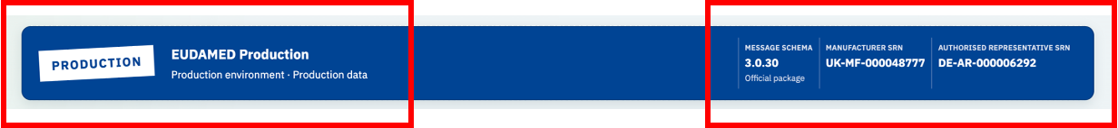

1.5.2 Application Navigation
The main menu provides access to the different areas of the application. It is arranged into Data Views, Submission Workspaces and Documentation. Select a button in the relevant group to open the required screen.
Under Data Views, select Submission Data to review the imported information and import controls, Canonical Validation to inspect device details and XML readiness, or Registration State to review the recorded position of parents and devices.
Under Submission Workspaces, select EUDAMED Submission to prepare registration and update files. Within that workspace, select POST, Patch XML, Market Info, Bulk POST, Bulk PATCH or Bulk Market Info for the required operation. Select Submission Summary to review recorded outcomes and available next actions. In Playground, the menu uses Testing Workspaces, EUDAMED Testing and Testing Summary.
Select Documentation to open the application guides and supporting information. Check that each menu button opens the expected screen and that the selected area is clearly shown. Selecting a menu option does not itself import data or submit anything to EUDAMED.
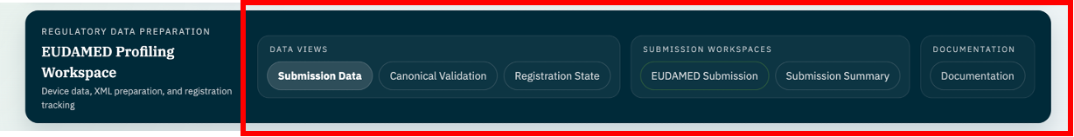

1.5.3 Submission Data
Submission Data provides the starting point for importing and reviewing device information. Data Snapshot shows the current imported data and database monitoring information, including Schema and Health. EUDAMED Activity provides access to recorded batch activity. In Production, Import Production Workbook assesses the prepared workbook and matching audit file before Enterprise Solutions reviews the results and confirms the import. Operators use the resulting data views after Enterprise Solutions completes the import and post-import checks.
Open Submission Data and check that Data Snapshot and EUDAMED Activity load without an unresolved error. Where an import already exists, check its details and device coverage against the expected input. Before the first import, an empty snapshot is expected. This basic check does not require running an import.
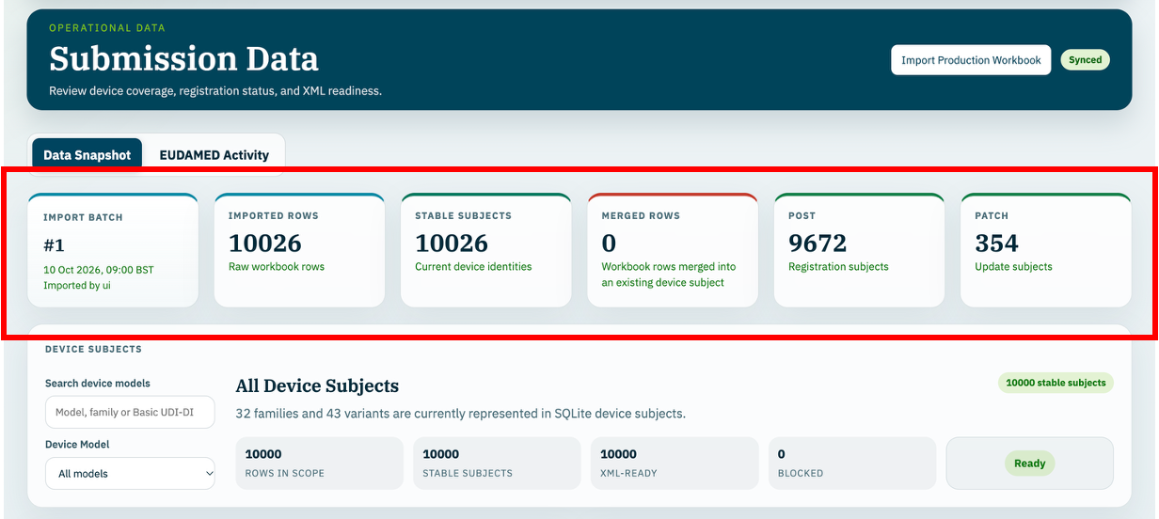

1.5.4 Canonical Validation
Canonical Validation shows how the imported device details are organised in the Canonical Model and linked to the fields used for EUDAMED XML. It provides model selection, source-to-parent mapping, field mapping and XML-readiness information. In Production, Completeness Notes identify broader missing information separately from XML Blockers.
Select a known model and check its family/model, sample catalogue number, Device UDI-DI and Basic UDI-DI against the imported information. Check that Source Sheet to Basic UDI and Canonical Mapping display the available values and their sources. Review XML Blockers before generating XML. An empty view is expected before the first import.
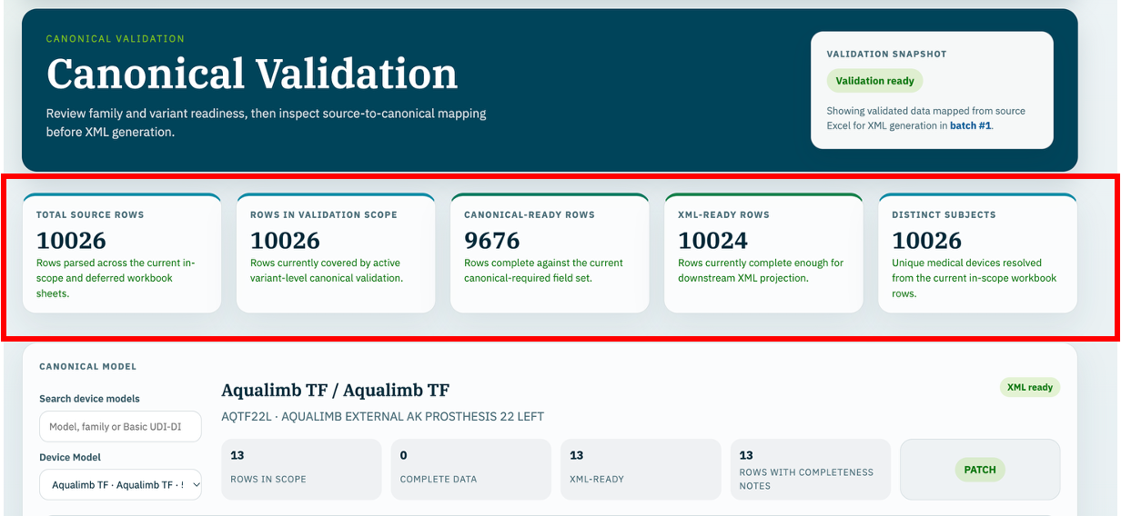

1.5.5 Registration State
Registration State shows the recorded registration position and operation readiness for the selected models. Parents & Children groups the devices under their Basic UDI-DI parent and shows registered, awaiting and unknown child statuses. The information comes from imported evidence and recorded responses; it is not a live view of the EUDAMED register, although correct use of the application as defined in this document, will enable the application to exactly reflect the EUDAMED registration position.
Refresh the counts, select a known model or search for a Basic UDI-DI, and check the results. Open Parents & Children and expand a resolved parent to inspect its devices, identifiers and statuses.
Check Previous and Next where more than one page is available. Parent registration, child registration and XML readiness are separate checks; an empty view is expected before the first import.
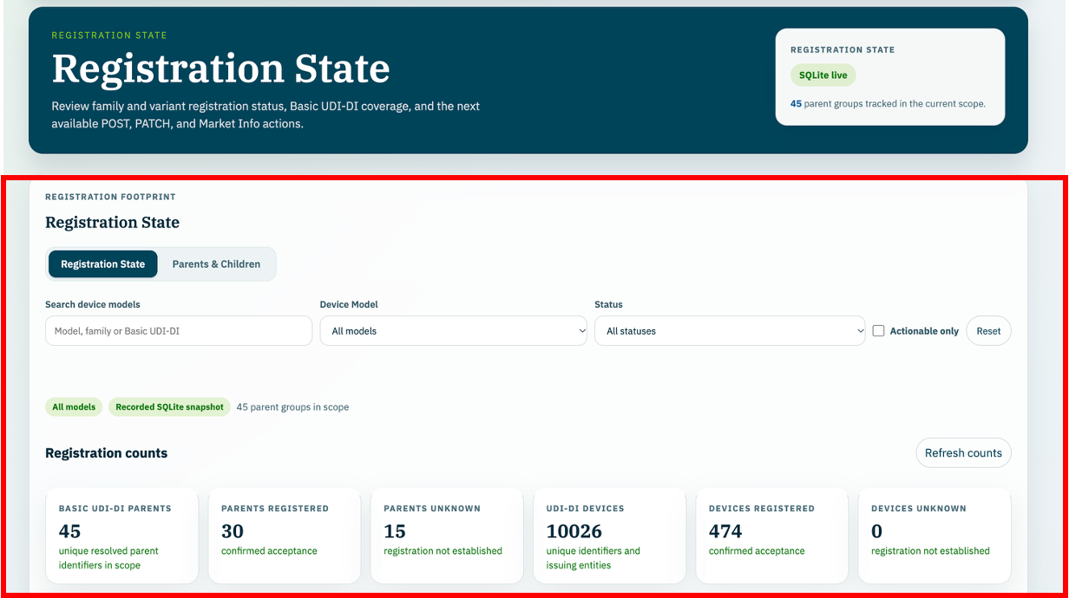

1.5.6 EUDAMED Submission
EUDAMED Submission is the workspace for selecting candidates and preparing registration or update files. It provides POST, Patch XML, Market Info, Bulk POST, Bulk PATCH and Bulk Market Info. The application assesses the selected records, generates and validates XML, and prepares ZIP downloads. The operator uploads the files to EUDAMED separately and imports the returned responses using Upload Success XML. In Playground, this workspace is labelled EUDAMED Testing.
Open the workspace and check that the operation tabs and model-selection controls are available. Select a known model and check that the assessment or blocking reasons are displayed for the chosen operation. A blocked operation can reflect missing data or registration prerequisites. This check does not require generating, downloading or submitting files.
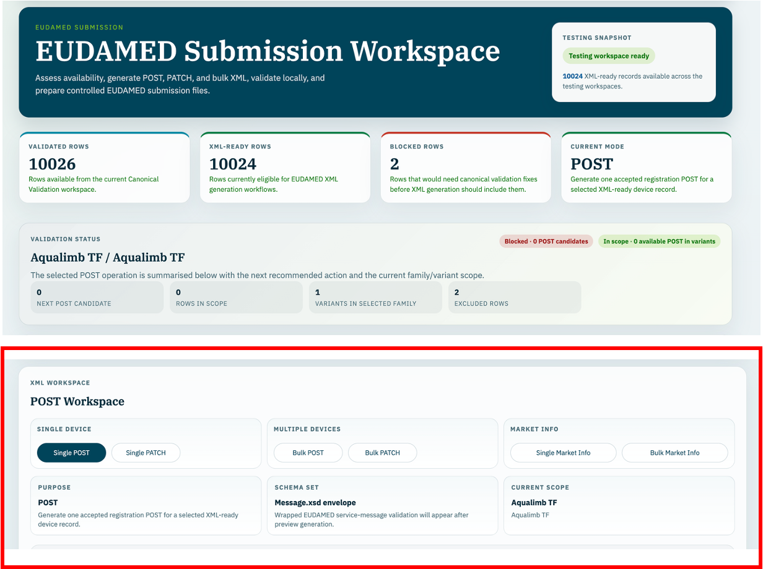

1.5.7 Submission Summary
Submission Summary brings together the recorded submission outcomes, registration position and available next actions. Model filters help the operator review recent results and event history for the relevant devices. Imported registration baselines remain separate from successful upload outcomes. In Playground, this screen is labelled Testing Summary.

Open the summary, select a known model and check that the displayed results and history follow the selection. Where a response has already been recorded, check a known device against its expected outcome. No submission history is expected before submissions and responses have been recorded.
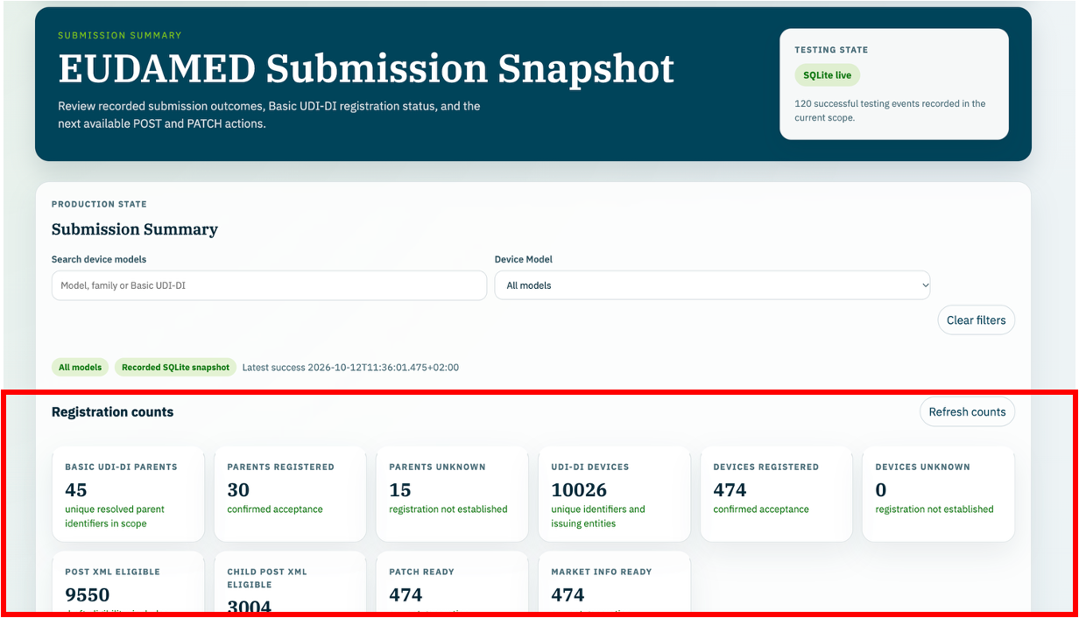

1.5.8 Documentation
Documentation provides the application guides and supporting information for data preparation, registration and updates. Documents are grouped in the navigation panel, and links within the displayed text allow the operator to open related information.
Open Documentation and select a guide from the navigation panel. Check that its text, tables and any relevant links display correctly. Use the Work Instruction for the agreed operating sequence and refer to the supporting guides where more detail is needed.
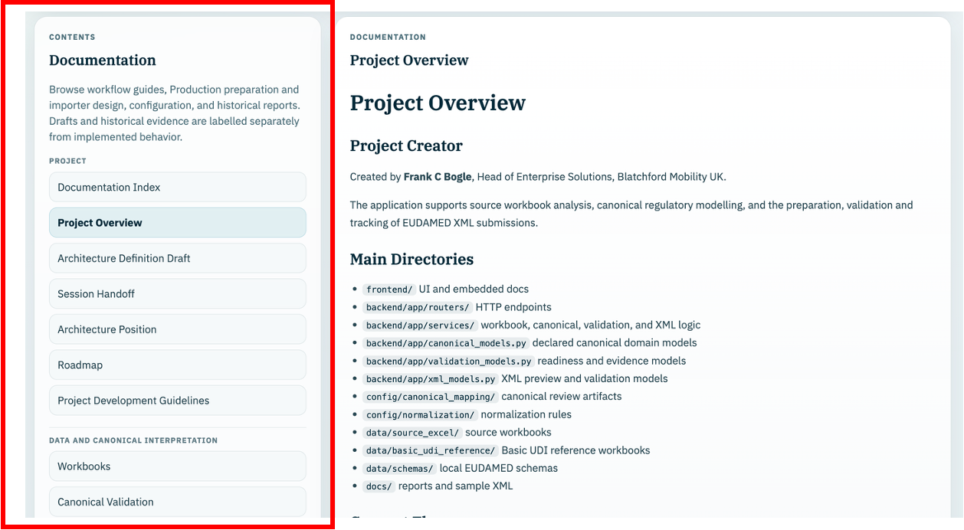

1.6 Associated Documents
The following documents and supporting information are supplied by Regulatory Affairs to Enterprise Solutions for receipt, checking and preparation of the EUDAMED import data:
- Template workbooks containing the device details for each device family or product group to be submitted.
- Basic UDI-DI list or workbook containing the parent identifiers, device models and associated parent details.
- Any EUDAMED registration exports or other registration information supplied by Regulatory Affairs to confirm the details of devices already registered. This activity requires access to the EUDAMED Production environment and Regulatory Affairs should generate the XML files needed to define the current registration position.
- Any additional supporting documents, corrected workbooks or written confirmation supplied by Regulatory Affairs to clarify device details, parent relationships, country information or which devices are to be included.
Enterprise Solutions checks that the files and supporting information relate to the devices being submitted and that the latest agreed versions are being used. The team retains the original information received from Regulatory Affairs with the records for the work.

1.7 Responsibility
The responsibilities for operating and supporting this process are as follows:
- Regulatory Affairs supplies Enterprise Solutions with the Template workbooks, Basic UDI-DI parent information, markets, device scope and supporting registration information, including the required EUDAMED XML extracts. It confirms the business information, resolves missing or conflicting details and provides agreed corrections.
- Enterprise Solutions is responsible for the complete import process. The team receives and checks the Template workbooks, Basic UDI-DI information and EUDAMED XML extracts from Regulatory Affairs; retains the source files; confirms the configured file locations; and resolves missing or conflicting information with Regulatory Affairs. It runs the preparation script, creates and reviews production-import.xlsx and its matching audit file, and checks the To Register, Registered and Summary tabs against the confirmed inputs. Enterprise Solutions then checks the application environment, reviews the import assessment, resolves blocking issues and confirms the import. The team retains the assessment/import reports, checks the resulting data and registration information, and confirms when the data is ready for the Operator to use for submissions.
- The trained Operator uses the imported data after Enterprise Solutions confirms that the import and post-import checks are complete. The Operator selects the devices for submission, generates and reviews the submission packages, uploads them to EUDAMED, retains and imports the returned responses using Upload Success XML, and checks the recorded outcomes. Questions about the imported source data or further workbook imports are referred to Enterprise Solutions.
- The application administrator maintains the intended environment and configuration.
- The document owner confirms responsibilities and release approval through the company document-control process.
- The Head of Enterprise Solutions provides technical oversight and support capability as required and can fulfil any of the other roles as required.

1.8 Records
It is important to retain the original Regulatory Affairs workbooks and receipt information, parent reference, original EUDAMED exports, prepared workbook and matching audit JSON, assessment/import reports, reviewed ZIP/XML packages, returned acknowledgements, exception decisions and evidence of final status. Enterprise Solutions retains the source files, receipt details, input-check decisions, prepared workbook, audit file, assessment/import reports and post-import check records. The Operator retains the submission packages, responses and submission outcome records.
Retain records in the company-designated repository and apply the applicable company access controls and retention requirements. The document owner is responsible for confirming these arrangements.

1.9 Definitions
Term | Meaning in this instruction
Basic UDI-DI / parent | Regulatory parent identifier shared by linked devices. Identify it together with its issuing entity.
Device UDI-DI / child | Identifier of an individual device record linked to a parent. Identify it together with its issuing entity; a catalogue number alone is not the regulatory identity.
Seed device | First child submitted with an unregistered parent using DEVICE.POST. The initial package includes parent and child data.
POST | Registration operation. DEVICE.POST registers a parent with its seed child; UDI_DI.POST adds children under an already registered parent.
PATCH | UDI_DI.PATCH updates a registered device using its tracked accepted baseline and next device version.
Market Information | Country information maintained by MARKET_INFO.PUT with its own versions, separate from device PATCH versions.
Accepted baseline | Tracked accepted device/market data from a matched successful acknowledgement or a supported Production export-baseline import. Proposed workbook data is not accepted evidence.
Playground / Production | Separate testing and live EUDAMED targets. The application confirms the connected backend environment in its banner.
Review Required / XML readiness | Review Required determines prepared-row import eligibility. XML readiness determines whether a specific operation can proceed; these are separate checks.

1.10 Safety Requirements
Non Applicable

1.11 Tools, Gauges, Fixtures
Non Applicable

2 Operating Instructions

2.1 Overview
Stage | Expected result / route
2.2 Receive and review | Enterprise Solutions receives the Regulatory Affairs source files, checks the input set and parent reference, and records exceptions.
2.3 Obtain and check updated workbooks | Enterprise Solutions checks updated workbooks and XML extracts for consistent structure, complete device coverage, parent details and export evidence before preparation.
2.4 Prepare and import device data | Enterprise Solutions creates and reviews the Import workbook and audit file, assesses and confirms the application import, retains the report and checks the resulting data before handover to the Operator. Only Review Required = No data rows are eligible. Import does not submit XML.
2.5 Register parent and seed | For an unregistered parent, generate DEVICE.POST containing its initial child and process the acknowledgement.
2.6 Register further children | For an accepted parent, generate UDI_DI.POST for eligible unregistered children and process each outcome.
2.7 Update devices | Use single Patch XML or Bulk PATCH against each device’s latest tracked accepted state.
2.8 Update Market Information | Use single or bulk Market Info for the explicit target countries and the next per-device Market Info version.
2.9 Reconcile and retain | Record errors and per-device outcomes, refer issues to Enterprise Solutions, reconcile responses and retain the evidence before resuming affected work.

Before new devices are submitted to EUDAMED, Enterprise Solutions checks that the structure of the Template workbooks supplied by Regulatory Affairs remains the same as the workbooks used previously. The team checks the worksheet names, column headings and arrangement of the device information. The application’s preparation and import functions rely on this structure. Enterprise Solutions reviews any changes before the files are used.
It is not necessary to remove devices that have already been imported from the supplied Template workbooks. The application identifies existing devices and adds new devices, leaving unchanged records in place. If previously imported device details have changed, the import assessment reports the differences, which must be reviewed before proceeding.
Enterprise Solutions checks the Basic UDI-DI list to confirm that parent details are available for all devices to be submitted. The team checks that each device can be linked to the correct parent and that the required parent information is complete. Enterprise Solutions refers missing or unclear parent details to Regulatory Affairs before preparing the Import workbook.

2.2 Receive and review Template workbooks from Regulatory Affairs

2.2.1 Required input set
Regulatory Affairs will provide Enterprise Solutions with the Template workbooks containing the device details and the Basic UDI-DI workbook containing the parent details. Before preparing the Import workbook, Enterprise Solutions checks that the files cover all the devices to be submitted.
The current set contains the following Template workbooks:
- Template for Accessories_Footspares EUDAMED 9th October.xlsx
- Template for Echelon family EUDAMED 9th October.xlsx
- Template for Elan MAX EUDAMED 9th October.xlsx
- Template for Elan products EUDAMED 9th October.xlsx
- Template for Elite family EUDAMED 9th October.xlsx
- Template for Epirus_Esprit EUDAMED 9th October.xlsx
- Template for MAX_Liner_and_Sleeve on EUDAMED 9th October.xlsx
- Template for Navigator_Javelin_Linx EUDAMED 9th October.xlsx
The parent details are provided in the following Basic UDI-DI workbook:
- BasicUDIs 9th October.xlsx
These filenames refer to the current supplied set. When Regulatory Affairs provides updated files, Enterprise Solutions checks the filenames and dates before use. The team records who supplied the files, when they were received and any missing or unclear details that need to be resolved.
For preparation that includes registered devices, Enterprise Solutions obtains the authorised EUDAMED XML extract set from Regulatory Affairs and checks its export date, query scope and returned pages. All supplied pages are retained. An export is dated evidence; it is not a continuously updated portal inventory.
The locations used for input files are defined by the internal design and configuration of the application’s import feature. Specific locations have been provided for the Template workbooks, Basic UDI-DI parent information, EUDAMED exports and prepared Import workbook with its matching audit file. Enterprise Solutions checks the configured locations for the environment in use and places the confirmed source files and prepared import files in the appropriate locations.
The application retains the imported device data and source information so that each record can be traced back to the information supplied. Enterprise Solutions retains the original source files in the designated locations as part of the records for the work. These locations form part of the agreed import and data-storage arrangements.
Enterprise Solutions confirms the Basic UDI-DI reference workbook selected for each preparation. The preparation process uses it for parent details and excludes it from scanning as a device Template workbook.

2.2.2 Expected Template structure
The table below describes the supplied workbook structure and the current preparation reader. Enterprise Solutions uses it when checking the received files. Header wording includes long guidance/examples and varies between files. Preserve the supplied text and column order; example answers in headers are not instructions to default device values.
Workbook element / field group | Expected structure and receipt check
Device workbook and sheets | Excel .xlsx files; model/variant worksheets contain a header row and populated device rows. The current reader searches the first 15 rows for an Issuing Entity header. A generic Sheet1 uses the workbook name as its device type.
Device identity | Headers begin Issuing Entity and UDI-DI code. Each populated device row must identify its issuing entity and Device UDI-DI. Preserve leading zeroes; GS1 UDI-DIs must already contain 14 digits. The utility does not infer padding.
Parent link | Basic UDI-DI supplies an explicit proposed parent when present. Otherwise the preparation requires an unambiguous model-name and issuer match to the parent reference. Missing/conflicting links require review.
Identification and description | Secondary UDI applicability, EMDN nomenclature, trade-name applicability/name, language, reference/catalogue number, direct marking, quantity, UDI-PI type and UDI-DI status. Check against the authorised source; preserve product identifiers as text.
Use and clinical characteristics | Clinical size applicability, single-use labelling, maximum-reuse applicability, sterilisation before use, sterile labelling, latex, CMR and endocrine-disrupting substance declarations. Unknown values require clarification rather than an assumed No.
Storage and warnings | Storage/handling applicability, condition types and descriptions, additional conditions, critical-warning applicability and type. Preserve repeated description columns and their associated conditions.
Other regulatory characteristics | Reprocessed single-use, Annex XVI purpose, manufacture by another person, clinical investigation, human/animal tissues, medicinal substances and human blood/plasma derivatives. Retain supplied fields even where later XML use requires further assessment.
Country information | First-placement Member State and available-market information, including additional country lists in headers where supplied. Obtain confirmed country choices; do not infer them from example text.
Parent reference workbook | Headers include Issuing Entity, Basic UDI-DI code and Device Model, with regulation, risk class, device characteristics, information URL and market fields. Current supplied sheets: Upload(BasicUDI not registered) and Update(BasicUDI registered). These names are source intent, not acceptance evidence.
Extra columns, duplicates and formulas | Retain business columns, populated unnamed columns and duplicate header occurrences. Conflicting duplicate device rows need review. Formula cells require cached values; missing caches are reported rather than calculated by the utility.

2.2.3 Receipt and review actions
Enterprise Solutions carries out all receipt and source-data checks in Sections 2.2.1–2.2.3. The following actions apply to the Template workbooks, Basic UDI-DI workbook and EUDAMED XML extracts, as relevant.
2.2.3.1 Preserve the supplied originals. Record receipt details and keep the parent reference distinguishable from the device workbooks.
2.2.3.2 Open each workbook read-only for review. Check the expected model/variant sheets, identifiable headers and populated device rows. Confirm the files represent the agreed scope and have not been replaced by an older set.
2.2.3.3 Check issuer, Device UDI-DI, catalogue number and Basic UDI-DI relationship. Identify missing identifiers, unexpected duplicates and conflicting parents. Do not repair leading zeroes or regulatory identifiers by assumption.
2.2.3.4 Check that proposed parent properties and country choices are supplied. Raise missing or contradictory information with Regulatory Affairs and record the agreed correction or exclusion.
2.2.3.5 Confirm the export date, scope and page set used for already registered devices. Keep exported accepted values separate from proposed Template values; missing export evidence must not be turned into an invented accepted version.
2.2.3.6 Record outstanding issues and authorised decisions. Unaffected records may proceed to preparation, which retains review reasons; affected rows must not be silently forced into an eligible state.
2.2.3.7 Enterprise Solutions confirms that the reviewed source set is ready for the updated-workbook checks in Section 2.3. Expected result: traceable inputs, a selected parent reference and documented scope/exception decisions. An example Template Workbook from Regulatory Affairs is shown below:
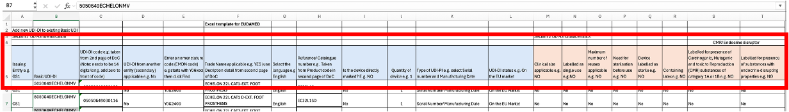
The Registration State menu within the application enables a view of Parent & Child registrations, from this User Interface it is possible to plan registration activities e.g., identify unregistered BASIC UDI-DI candidates and the number of related children DEVICE UDI-DI candidates.
In this example, the Parents & Children view is filtered based on Elan and displays the BASIC UDI-DI details for registration and numbers of related DEVICE UDI-DI.
Notice the NEXT STEP information, in this case the application is guiding the Operator to create the seed POST to review the BASIC UDI-DI Parent XML prior to generating and uploading the details.
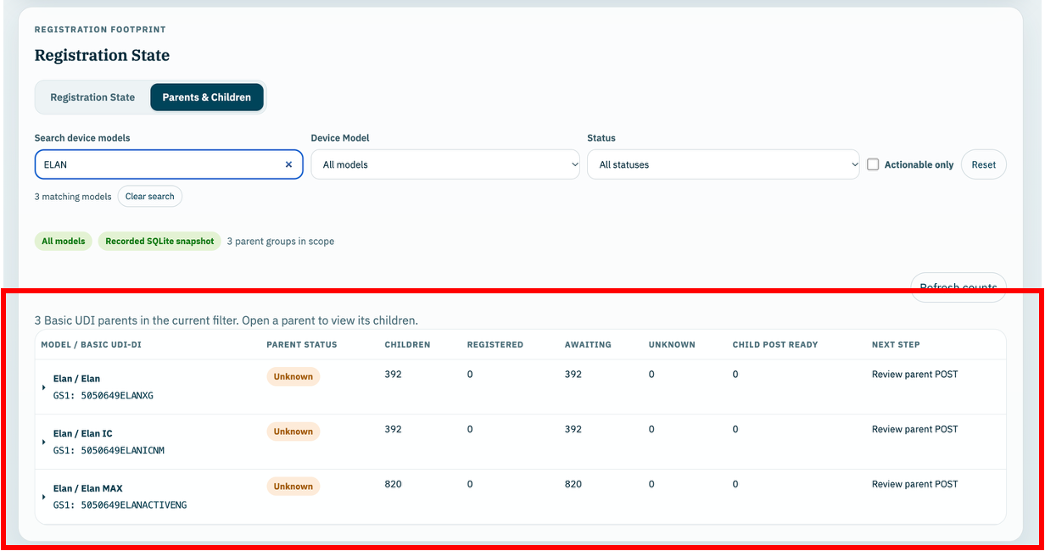

2.3 Obtain and check updated Template workbooks
Enterprise Solutions obtains the updated Template workbooks, Basic UDI-DI list and required EUDAMED XML extracts from Regulatory Affairs. The team carries out all the checks in this section to confirm that the files contain the required device and parent details and can be used with the application’s preparation and import functions.
2.3.1 Obtain the latest agreed Template workbooks, Basic UDI-DI workbook and EUDAMED XML extracts. Enterprise Solutions confirms with Regulatory Affairs which device families, models and individual devices are included in the update and which registration exports support it. Record the filenames, revision or issue date where available, export date and scope, and the date received. Retain the files as supplied and check the XML page set as described in Section 2.2.3.
2.3.2 Compare the structure with the previously used Template workbooks. Check the worksheet names, column headings, column order and the position of the header and device rows. Check that required columns have not been removed or renamed and that additional worksheets or columns have been identified. Refer structural changes for review before the files are used, because the preparation and import functions rely on the agreed workbook structure.
2.3.3 Check the workbook population against the device list or scope confirmed by Regulatory Affairs. Compare the families, models and devices with the previous workbooks, taking account of the additions and any agreed changes. Check that every device intended for registration has a populated row and that no devices have been omitted. Investigate missing rows, unexpected duplicates and unexplained changes in device counts.
2.3.4 Check the identifiers for each new device. Confirm that the issuing entity, Device UDI-DI, catalogue number and Basic UDI-DI parent link are available and consistent. Preserve leading zeroes and obtain clarification where identifiers or parent links are missing or conflicting.
2.3.5 Check that the Basic UDI-DI list includes every parent needed for the devices in the updated workbooks. For any new Basic UDI-DI, obtain the parent identifier, issuing entity, device model and the other required parent details from Regulatory Affairs. Confirm that the new devices are linked to the correct parent; do not proceed with missing or assumed parent details.
2.3.6 Leave previously imported devices in the workbooks. The application identifies existing devices and adds new devices without duplicating unchanged records. Review any reported differences where existing device details have changed. An omitted source row must not be treated as an instruction to delete an application record.
2.3.7 Enterprise Solutions resolves any missing information, structural changes or differences with Regulatory Affairs and records the agreed outcome. Once the source set is confirmed, the team creates and reviews the Import workbook and matching audit file as described in Section 2.4.

2.4 Prepare and import the device data
Enterprise Solutions receives the Template workbooks, Basic UDI-DI workbook, EUDAMED XML extracts and any supporting information directly from Regulatory Affairs. The team completes the receipt and input checks in Sections 2.2 and 2.3 before preparing the import files. Enterprise Solutions carries out the preparation, application assessment, import and post-import checks described below.
Enterprise Solutions checks that the files are in the locations configured for the application and runs the preparation script. This combines the device and parent details with the supplied EUDAMED registration exports to create production-import.xlsx and its matching audit file. Any additional information or exceptions must be reviewed before the files are prepared.
Enterprise Solutions reviews production-import.xlsx, including the To Register, Registered and Summary tabs, and its matching audit file. The team checks the prepared device and parent details against the confirmed source information. Missing information, conflicting details and records requiring review must be resolved with Regulatory Affairs or their exclusion understood and recorded. Enterprise Solutions confirms that the reviewed files are ready for assessment and import.
Enterprise Solutions checks that the environment banner confirms Production and opens Submission Data. Selecting Import Production Workbook runs an assessment of the configured Import workbook and matching audit file without committing the import. The assessment identifies new and unchanged devices, skipped records, differences in existing device details and XML-generation blockers. Enterprise Solutions reviews these results and resolves any blocking issues before selecting Confirm Production Import. Any reported differences in existing device details must be reviewed and resolved with Regulatory Affairs where required before the import can proceed.
Following import, Enterprise Solutions retains the import report and checks the updated information in Submission Data, Canonical Validation and Registration State. The team confirms the expected device coverage, parent links and recorded registration position, and records any outstanding XML blockers or other exceptions. Once the import and post-import checks are complete, Enterprise Solutions informs the Operator that the data is ready for submission activities and identifies any devices that must not proceed until outstanding issues are resolved. Importing the data does not submit it to EUDAMED.
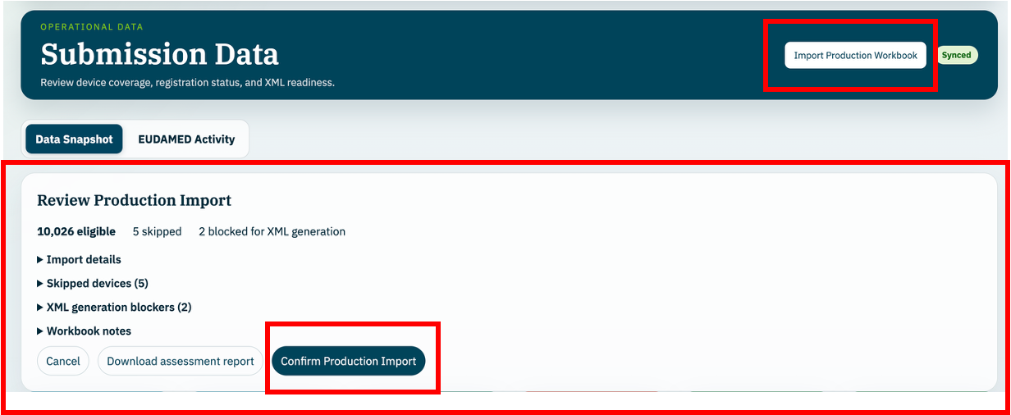

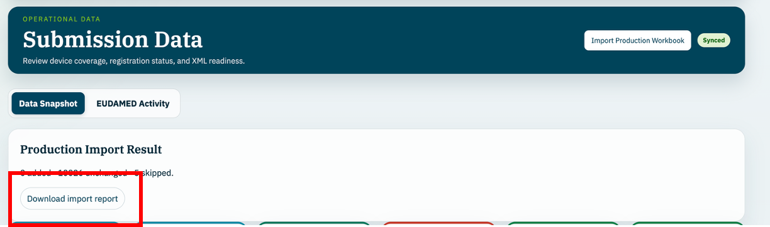

2.5 Register an unregistered Basic UDI-DI and its seed device
The Operator uses this process to register a Basic UDI-DI parent together with its first Device UDI-DI, referred to as the seed device. Enterprise Solutions must have completed the import and post-import checks first. ELAN22L1S is used below as an example; check the current assessment before proceeding, because the example may already have been registered when this instruction is used.
2.5.1 Open Registration State and select Parents & Children. Refresh the counts and search for the relevant Basic UDI-DI or device family/model. Check the parent identifier and its issuing entity, its recorded registration status, the linked children and the suggested next step. Identify a parent awaiting registration and a suitable seed device. Resolve unknown status or conflicting registration evidence before proceeding.
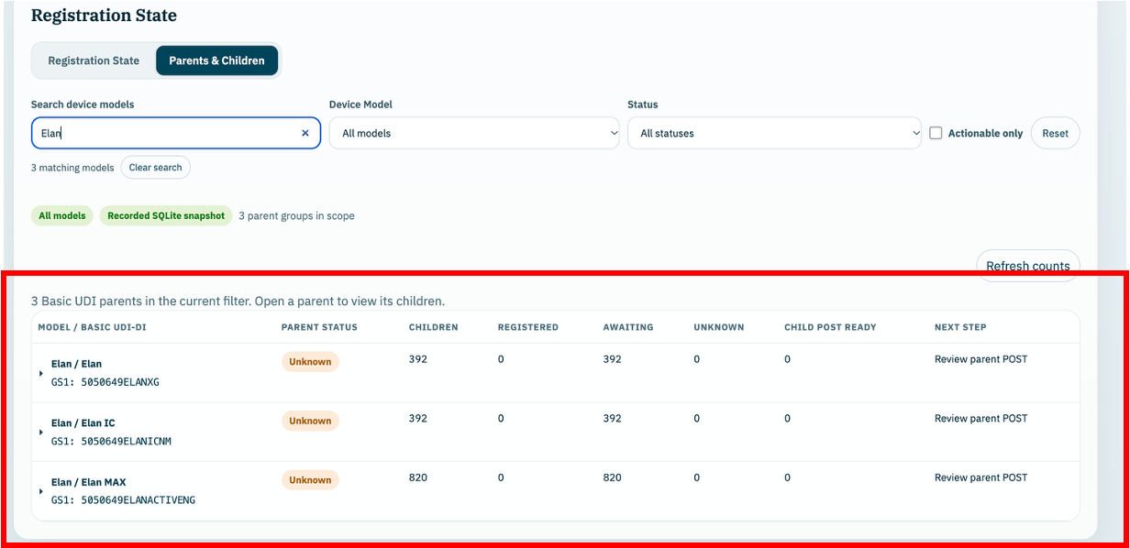
2.5.2 Open EUDAMED Submission and choose Single POST. Use the model selector to search for the Basic UDI-DI or family/model name and select the matching entry. Check that the selected parent, model, catalogue number and Device UDI-DI are the intended records. In Playground the workspace is labelled EUDAMED Testing.
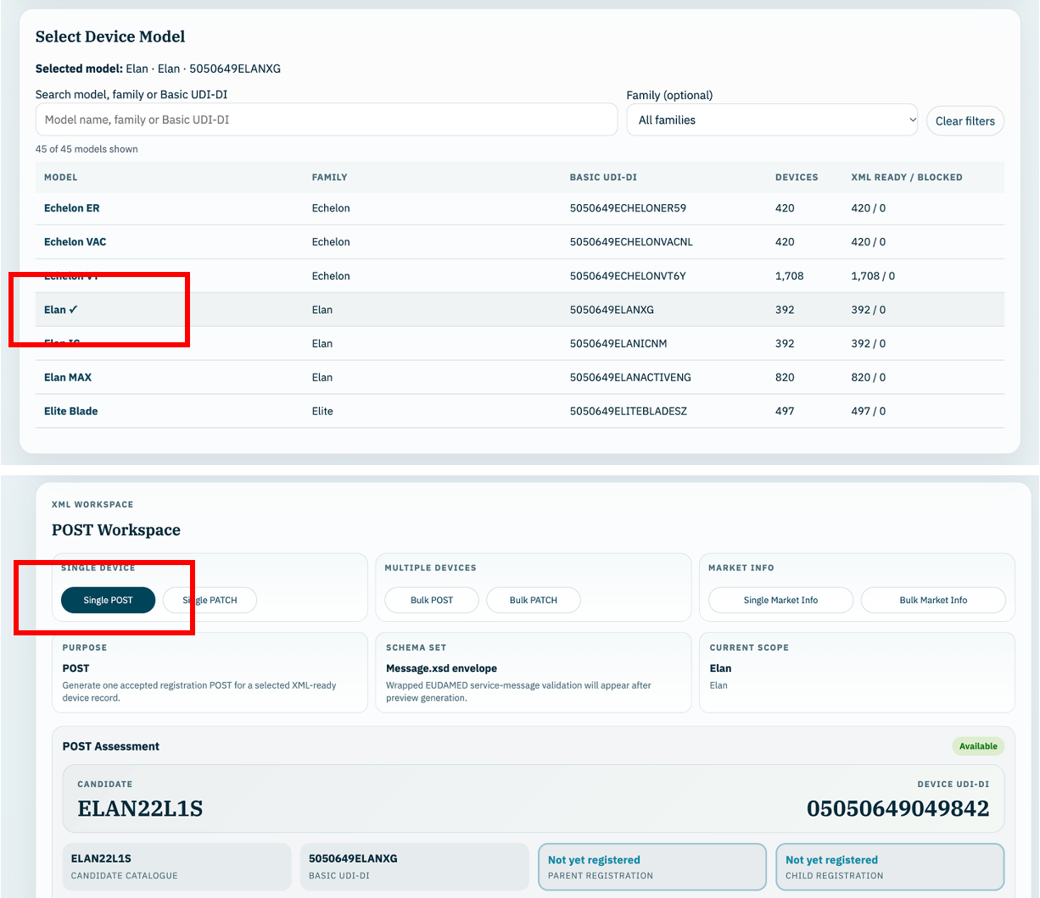
2.5.3 In the Interpretation area, check that the application reports: “POST is available for ELAN22L1S. This record can seed a new Basic UDI-DI parent registration.” For another candidate, the catalogue number in this message must match that device. Proceed only when the assessment confirms the parent-and-seed operation is available. If the message says the parent is already registered, use the child-only registration process in Section 2.6 instead.
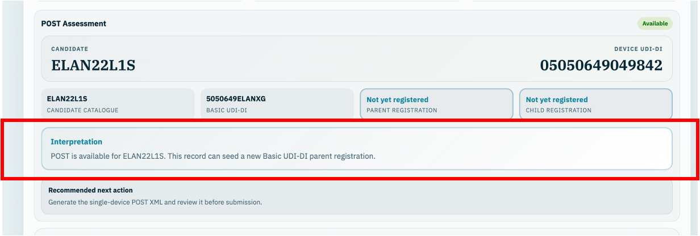
2.5.4 Select Generate POST and inspect the XML in POST Preview. Check the message uses DEVICE.POST and includes the intended Basic UDI-DI parent and seed Device UDI-DI, the correct actor identifiers and the required device and market details. Check that local XSD validation passes. Resolve any errors or unexpected details before downloading or submitting the payload.
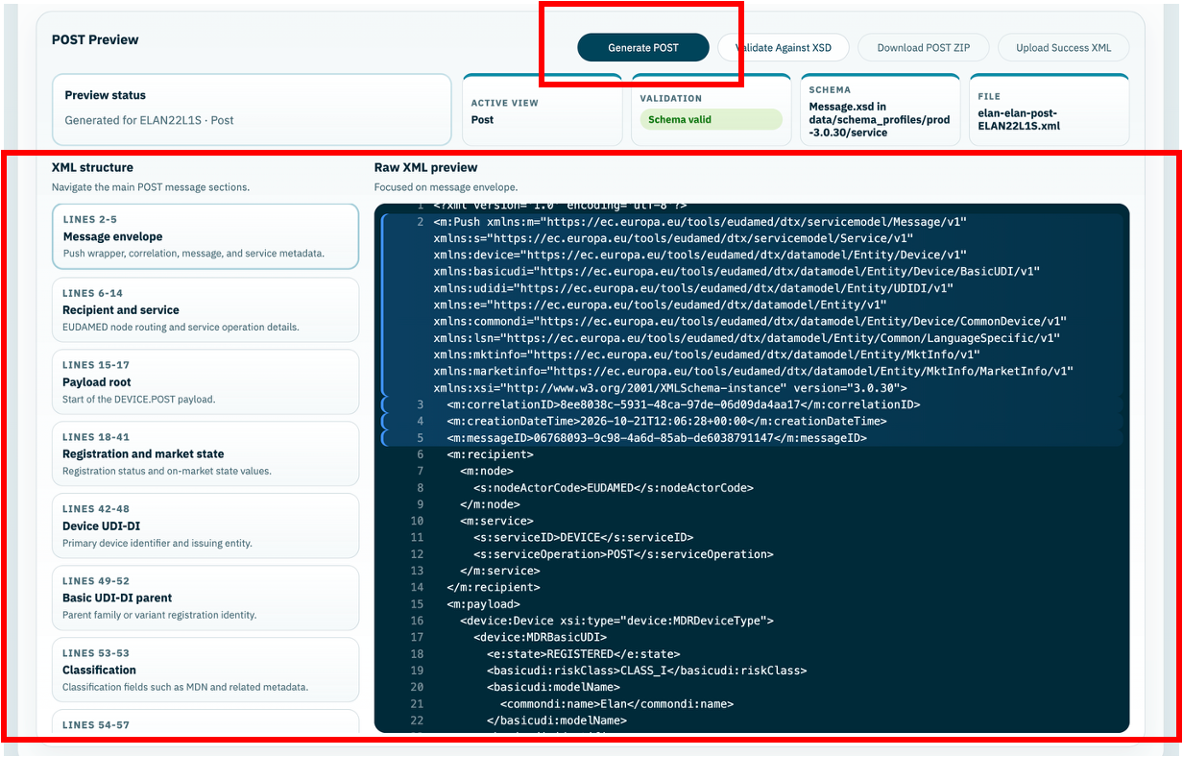
2.5.5 Select Download POST ZIP. Record the ZIP filename and the local folder where it was saved, and retain this exact package as the submission record. Check that the XML in the downloaded package relates to the reviewed parent and seed device. Keep the ZIP intact and extract its DEVICE.POST XML for portal upload; supporting manifest or review files are not the submission XML. If the selection or proposed submission is changed, generate and review it again and download a new ZIP.
2.5.6 Authenticate to the intended EUDAMED Portal using the authorised account. Check that the portal environment and active manufacturer actor match the application environment and the actor identifiers in the XML. Use the permissions required for bulk device upload; the Commission training guide identifies the UDI/Devices Confirmer profile for this activity.
2.5.7 In the portal, open Data transfer, then Bulk Upload, then New upload. Select “Upload of Legacy / Regulation Device / SPP (Basic UDI and UDI-DI / Master UDI-DI)”. This is the DEVICE.POST service for a new parent with its first child. The option for adding a child under an existing parent belongs to Section 2.6.
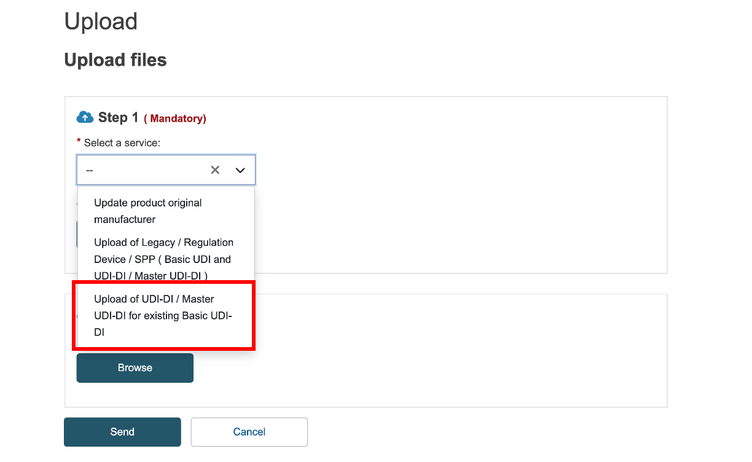
2.5.8 Select the reviewed DEVICE.POST XML extracted from the recorded ZIP, check the selected service and filename, and submit the upload. Record the portal upload/reference identifier where available, together with the submission date and time. Await processing and review the returned outcome; completion of the upload alone does not confirm registration.
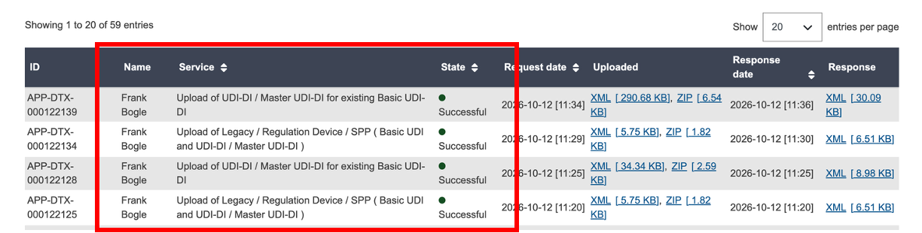
2.5.9 Download and retain the returned XML response with the submission package. Check the result for the Basic UDI-DI and the seed Device UDI-DI. If the response reports an error, retain its details and resolve it before attempting a dependent submission. Check any partial outcome at the individual parent/device level.
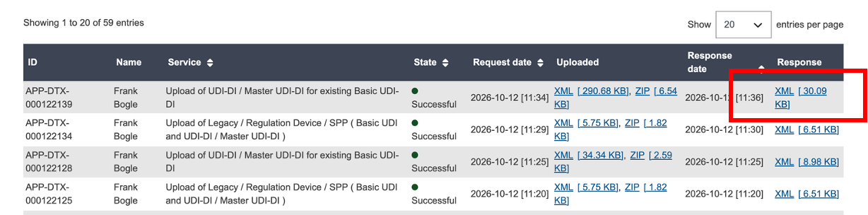
2.5.10 Mandatory final step: Upload Success XML. Return to the same parent/device in EUDAMED Submission and select Upload Success XML to import the XML response returned by EUDAMED for this submission. Refresh Registration State and Parents & Children and check that the recorded outcome for both the Basic UDI-DI parent and seed Device UDI-DI agrees with the EUDAMED response. Continue with Section 2.6 only when the response has been imported and the required parent acceptance is confirmed. Registering the seed does not register the remaining children.
Upload Success XML MUST be completed for every submission response. The Loader does not automatically receive the portal outcome. Until the response is imported, its recorded registration status may remain out of date, even if EUDAMED has accepted the registration. This step keeps the Loader aligned with the actual EUDAMED outcome for the submitted parent and device. Do not treat the process as complete until the response is imported and the resulting status has been checked. If the import fails or the statuses do not agree, retain the response and refer the issue to Enterprise Solutions before continuing.
Expected result: EUDAMED has confirmed the intended Basic UDI-DI parent and seed device registration, the matching response has been imported using Upload Success XML, and Registration State / Parents & Children reflects that outcome. The process is complete only after these checks. Retain the ZIP, submission reference and returned response.
Portal navigation and service reference:European Commission Devices Module Training, pages 39–40 (September–October 2025).

2.6 Register devices under an already registered Basic UDI-DI
This process adds new Device UDI-DIs under a Basic UDI-DI parent that is already registered. Follow the review, file-retention, portal authentication and response-handling approach in Section 2.5, with the changes below. Bulk POST registers additional children; it does not create or update the parent.
2.6.1 Check the registered parent and remaining children. In Registration State, open Parents & Children and locate the required Basic UDI-DI or family/model. Confirm the parent is registered, then identify the children awaiting registration. If the parent was seeded using Section 2.5, its successful response must already have been imported. Do not include the registered seed or other already registered children. If parent registration is not confirmed, resolve this before proceeding.
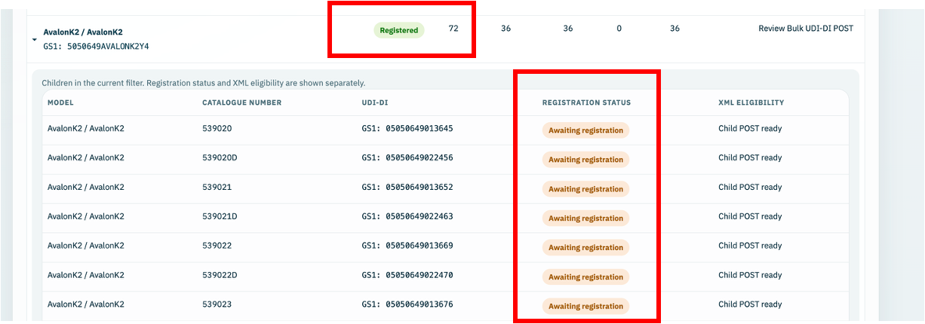
2.6.2 Select the Bulk POST candidates. Open EUDAMED Submission, select the relevant family/model and choose Bulk POST. In Package scope, choose the required Scope mode. For specific devices, choose Select catalogue numbers, open Select devices, select the required catalogue numbers / Device UDI-DIs and select Apply selection. Alternatively, use an appropriate next-device preset or All eligible devices. Check the selected count, parent links and any excluded or unmatched records; do not assume every child under the parent is eligible.
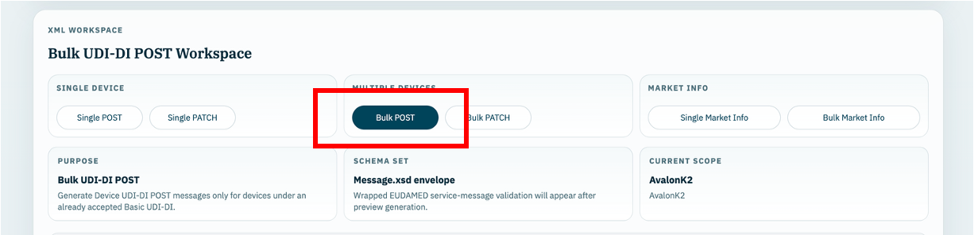
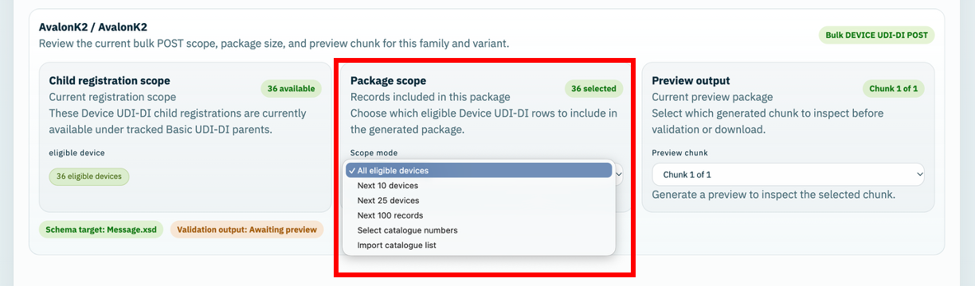
2.6.3 Check the assessment, generate and download. Confirm that the assessment allows child Device UDI-DI registration under an already registered parent. Select Generate Bulk DEVICE UDI-DI POST. Inspect each generated preview chunk and check the XML uses UDI_DI.POST, links to the intended existing Basic UDI-DI and includes the selected eligible children. Check local validation and the actual included/excluded records before selecting Download Bulk DEVICE UDI-DI POST ZIP. Record the ZIP filename and local folder and retain the exact package, as in Section 2.5. Retain the ZIP and use its reviewed UDI_DI.POST XML files for the portal uploads.
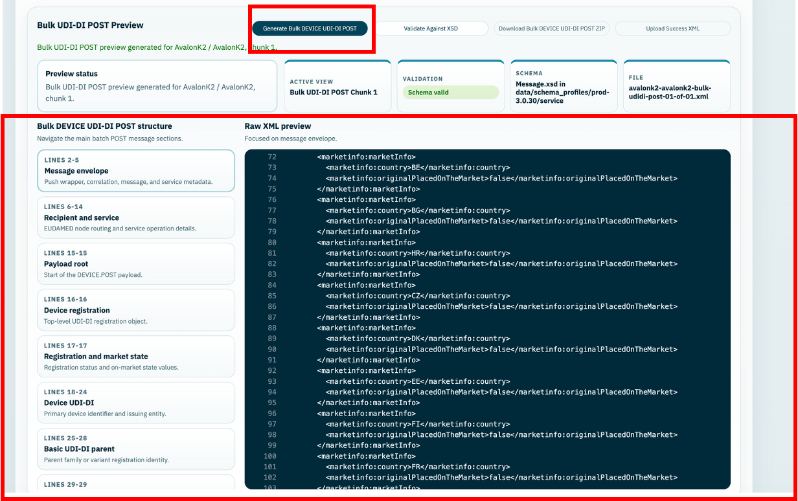
2.6.4 Use the child-registration portal option. Authenticate and check the portal environment and manufacturer actor as described in Section 2.5. Under Data transfer, Bulk Upload, New upload, select “Upload of UDI-DI / Master UDI-DI for existing Basic UDI-DI”. This invokes UDI_DI.POST for additional children. Submit each reviewed XML file from the downloaded package and retain the upload/reference identifiers. Await processing and check each device outcome, including any partially successful result. The parent-and-seed option used in Section 2.5 is not the service for this operation.
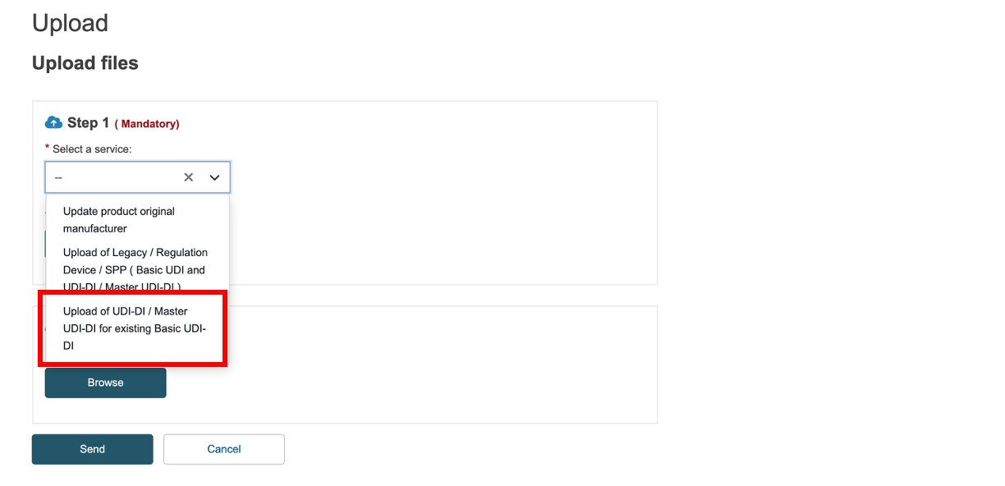
2.6.5 Mandatory final step: Upload Success XML. Download and retain the response for every submitted XML file, return to the corresponding Bulk POST selection in EUDAMED Submission and use Upload Success XML to import each returned response. Refresh Registration State and Parents & Children and check which selected devices are now registered and which still require action. Investigate failed or unmatched outcomes before retrying; do not resubmit the successfully registered children.
Upload Success XML MUST be completed before this activity is considered complete. The Loader does not automatically receive EUDAMED portal outcomes. Importing every returned response and checking the per-device results keeps its recorded status aligned with the actual registration outcome for the submitted devices. Refer response-import failures or unexplained differences to Enterprise Solutions.
Expected result: the existing parent remains registered, successfully accepted additional Device UDI-DIs are recorded as registered, and any failed devices remain identified for action. The packages, upload references and responses are retained.
Portal navigation and service reference:European Commission Devices Module Training, pages 39–40 (September–October 2025).

2.7 Update registered devices using PATCH
Follow Sections 2.5 and 2.6 for the common submission steps. This section describes the checks and controls specific to PATCH.

2.7.1 Purpose and prerequisites
Use PATCH to change supported details of devices that are already registered. The Operator must have an agreed change and the Loader must hold the latest accepted device details and Market Information for each selected device. PATCH updates the child Device UDI-DI; it does not register a new device or change the Basic UDI-DI parent.
Check Registration State / Parents & Children and the operation assessment before proceeding. Resolve missing accepted baselines, unresolved registration evidence or Market Information blockers with Enterprise Solutions. Use only scenarios currently enabled by the application; availability does not itself establish that every proposed change will be accepted by EUDAMED.

2.7.2 Select the devices and PATCH operation
Open EUDAMED Submission and select the relevant family/model. Choose Patch XML for a single device or Bulk PATCH for a selected group. For a single device, check the catalogue number, Device UDI-DI and parent link. For a bulk update, select the required devices using the available scope controls and check the actual selected count and any exclusions.
Confirm that the assessment allows PATCH for the intended records and that the accepted baseline is loaded. A bulk selection can contain devices at different accepted versions; the application assesses each device separately. Do not assume all children under a registered parent are eligible for PATCH.
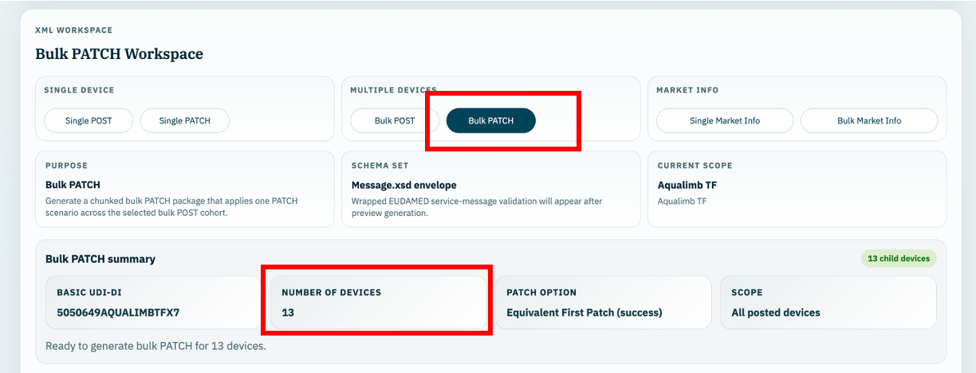

2.7.3 Enter and review the proposed changes
Select the enabled scenario that matches the agreed change and enter the required values. For Bulk PATCH, confirm that the same scenario and entered values are appropriate for every selected device. Review the before/after comparison against the latest accepted details, rather than assuming the current Template workbook represents the accepted EUDAMED record.
Check the proposed device version for each record. Retain the accepted non-target details and the latest accepted country list, including any earlier Market Information changes. Where the application allows an Equivalent First Patch, this is a first-update scenario at device version 2 and does not introduce a business-field change. Refer unsupported changes or unexpected comparisons to Enterprise Solutions before proceeding.
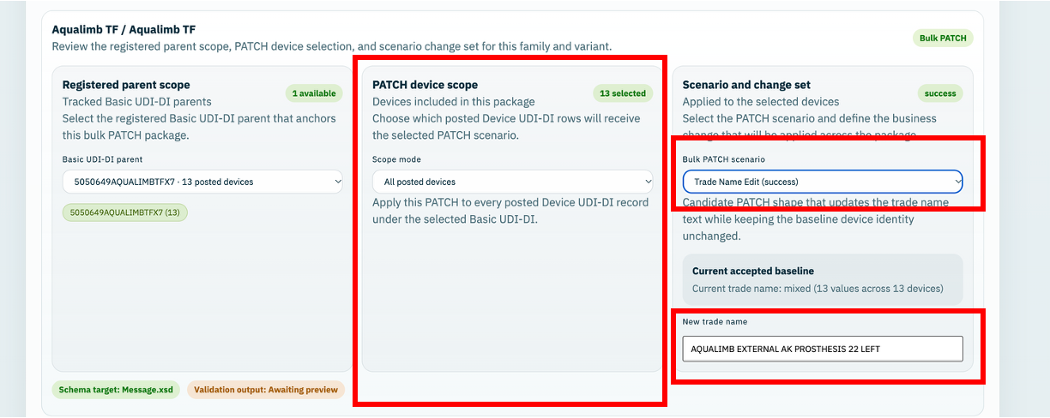

2.7.4 Generate and submit the PATCH
For a single device select Generate Patch Scenario, inspect the UDI_DI.PATCH XML and check local XSD validation before selecting Download Patch Scenario ZIP. For Bulk PATCH use Generate Bulk PATCH and Download Bulk PATCH ZIP, reviewing each preview chunk, its device versions and the actual included/excluded records.
Follow Sections 2.5 and 2.6 for review of the exact downloaded contents, recording the ZIP location, portal authentication, upload references and response retention. For this operation, select “Update of UDI-DI / Master UDI-DI” under Data transfer, Bulk Upload, New upload. Submit the reviewed UDI_DI.PATCH XML from the retained package. If the proposed submission or selection changes, repeat the review and download before submission.

2.7.5 Record and verify the outcome
Retain the returned response for every submitted XML file and import it using Upload Success XML in the corresponding PATCH workspace. Follow the per-device response checks in Sections 2.5 and 2.6, including mixed success/error outcomes. Check that each accepted update has the intended values and device version and that non-target details and accepted countries remain correct.
Check Registration State, Parents & Children and the available accepted-state / submission history for the selected devices. Resolve rejects and discrepancies before a dependent update. Do not treat a preview, download or portal upload alone as proof that the device details have changed in EUDAMED.
Upload Success XML MUST be completed for every returned response, followed by a check that the Loader reflects the accepted EUDAMED outcome for each submitted device. The Loader does not automatically receive portal results. This activity is not complete until the responses are imported and the resulting state has been checked.
Portal navigation and service reference:European Commission Devices Module Training, pages 39–40 (September–October 2025).

2.8 Update Market Information using PUT
Follow Sections 2.5 and 2.6 for the common submission steps. This section describes the checks and controls specific to Market Information PUT.

2.8.1 Purpose and prerequisites
Use Market Information PUT to change the countries where registered devices are made available. The Operator must have the agreed country list and the application must have sufficient accepted registration and Market Information evidence for the selected devices. Check the operation assessment and refer missing or conflicting information to Enterprise Solutions.
Market Information has its own country snapshot and version. A successful MARKET_INFO.PUT does not advance the device PATCH version or register additional devices. A later PATCH must retain the latest accepted country list.

2.8.2 Select the devices and Market Info operation
Open EUDAMED Submission and select the relevant family/model. Choose Market Info for a single device or Bulk Market Info for a group. Check the selected catalogue numbers, Device UDI-DIs, Basic UDI-DI links, eligibility and any excluded records before entering the change.
For Bulk Market Info, select only devices that should receive the same final country list. The devices may have different current countries or Market Information versions; the application resolves the current evidence and proposed version separately for each device.
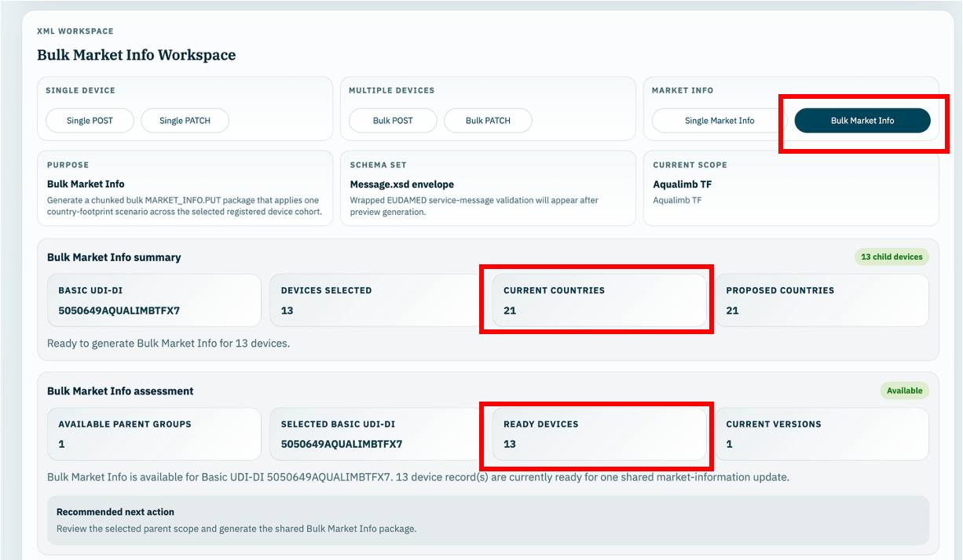

2.8.3 Enter and review the proposed countries
Review the current accepted countries and use the country-selection controls to enter the complete intended country list. Include every country that must remain, as well as any additions, and remove only those countries covered by the agreed change. This is the target list, not a list of additions to be appended to the current countries.
Compare the current and proposed countries before generating the XML. Check the proposed Market Information version against the version evidence displayed by the application. An observed higher EUDAMED version can raise the minimum next version; it does not prove acceptance of a previously rejected country list. Do not substitute the device PATCH version or force a lower Market Information version.
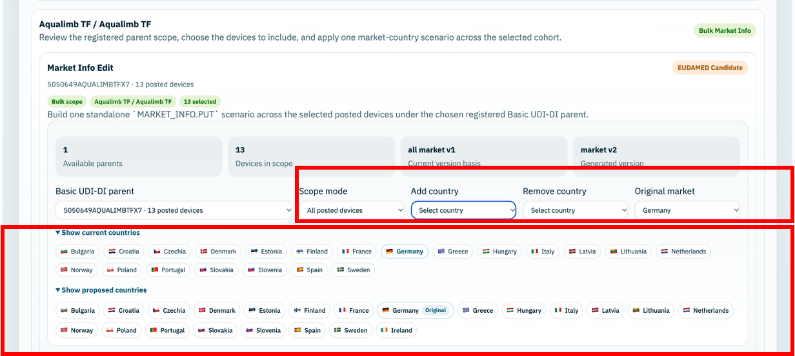

2.8.4 Generate and submit the Market Information PUT
For a single device select Generate Market Info, inspect the MARKET_INFO.PUT XML and check local XSD validation before selecting Download Market Info ZIP. For a group use Generate Bulk Market Info and Download Bulk Market Info ZIP, reviewing each preview chunk, its device identities, final countries and per-device Market Information versions.
Follow Sections 2.5 and 2.6 for the shared review, ZIP-location, portal-authentication, upload-reference and response-retention steps. For this operation select “Update market information” under Data transfer, Bulk Upload, New upload. Submit the reviewed MARKET_INFO.PUT XML from the retained package. If the countries or selection change, generate, review and download a new package before submitting.

2.8.5 Record and verify the outcome
Retain the response for every submitted XML file and import it using Upload Success XML in the corresponding Market Info workspace. Check each device outcome, including any partially successful bulk result. Verify that accepted devices show the intended countries and the confirmed Market Information version, with the device PATCH version unchanged.
Review the accepted country information and recorded event details in the application, and check Registration State / Parents & Children for the resulting operational position. Resolve response-import failures, version rejects or unexplained differences with Enterprise Solutions before dependent changes. A rejected response or observed version floor does not establish acceptance of the proposed countries.
Upload Success XML MUST be completed for every returned response, followed by a check that the Loader reflects the accepted EUDAMED outcome for each submitted device. The Loader does not automatically receive portal results. This activity is not complete until the responses are imported and the resulting state has been checked.

Portal navigation and service reference:European Commission Devices Module Training, pages 39–40 (September–October 2025).

2.9 Handle exceptions and retain submission records
If an error or unexpected outcome occurs, the Operator must stop the affected activity, retain the information needed to investigate it and refer the issue to Enterprise Solutions. The categories below describe the main situations that may be encountered; the exact message and affected devices must always be recorded.

2.9.1 Identify the error and preserve the records
Check whether the issue occurred in the Loader, during XML generation, in the EUDAMED Portal or when importing a response. Record the full message, date/time, operation, environment and affected Basic UDI-DI / Device UDI-DIs. Keep the exact downloaded ZIP and any returned response. Do not manually edit submission XML, application records or versions to bypass an error.

2.9.2 Possible error outcomes
Error or outcome | Operator action | Enterprise Solutions follow-up
Environment unconfirmed, wrong actor or connection failure | Stop the affected activity. Record the message and the environment shown. Do not submit while the environment or manufacturer actor is uncertain. | Check the running environment, actor settings, connectivity and access before confirming that work can resume.
Expected parent/device missing, operation blocked or no eligible candidates | Retain the selection and readiness details and refer the issue to Enterprise Solutions. Do not register an identity again merely because it is absent from a selection list. | Check import coverage, source identity, recorded acceptance, parent/child links and operation readiness; resolve source questions with Regulatory Affairs.
Source/import file, lock, audit mismatch or changed-data error | Refer the message to Enterprise Solutions. Operators do not replace prepared files, run scripts or force an import. | Review the confirmed sources, workbook/audit pair and configuration, resolve the error and repeat assessment before import.
XML generation or local XSD validation fails | Retain the validation message and affected identifiers. Do not upload XML that fails local validation. | Investigate source data, projection or schema/configuration issues and arrange corrected generation and review.
Portal access, permission or service-selection error | Record the portal message and selected service. Stop the upload and refer to Enterprise Solutions. | Check the account/actor permissions, environment and operation against the XML service and coordinate access correction where required.
Already-registered, duplicate-device or version-conflict response | Retain the response and attempt to import it using Upload Success XML. Do not change identifiers or increment versions by guesswork. | Reconcile current acceptance, generated context and version evidence before advising whether a corrected update or another action is needed.
Market Information rejection or PATCH country/baseline blocker | Retain the exact message and response. Refer the issue before another dependent PATCH or country update. | Review accepted countries, Market Information versions, observed version evidence and any unresolved rejection. Confirm the correct next operation.
Upload pending, interrupted or timed out; outcome unknown | Keep the package and portal reference. Check the existing upload outcome and refer uncertainty to Enterprise Solutions before resubmitting. | Establish whether EUDAMED processed the request and recover the response or agree the next action. An unknown result is not proof of failure.
Partially successful bulk submission | Retain and import all returned responses. Identify success and error results per device; do not repeat the entire batch without review. | Reconcile each outcome, resolve failed records and confirm the scope of any retry so accepted devices are not resubmitted.
Upload Success XML fails, response is unmatched or Loader status differs from EUDAMED | Retain the original response, exact submitted package and error details. Stop dependent actions and refer to Enterprise Solutions. | Check the matching device/message context and accepted-state history, resolve the import or reconciliation issue and verify the resulting status.
Other rejected or unexpected outcome | Retain the full message, returned response and affected identifiers and refer to Enterprise Solutions. Do not attempt an unsupported workaround. | Investigate the specific error, obtain business clarification where necessary and confirm the corrective action.

2.9.3 Refer the issue to Enterprise Solutions
Provide Enterprise Solutions with the following information so that the issue can be reproduced and reconciled:
- The environment and operation in use, including whether the action was Single or Bulk.
- The device family/model, Basic UDI-DI, catalogue numbers and Device UDI-DIs affected.
- The full application or portal error message and a screenshot showing the selected scope and outcome.
- The exact downloaded ZIP filename and local location, together with any portal upload/reference identifier and submission date/time.
- The original returned XML responses and the result of each Upload Success XML attempt.
- For bulk work, the devices confirmed successful, those rejected and those whose outcome is still unknown.
Enterprise Solutions investigates technical, import, identity, baseline and version issues and obtains confirmation from Regulatory Affairs where business data or registration evidence needs correction. The team confirms the corrective action and identifies which records, if any, may be retried.

2.9.4 Resume work and verify the result
Resume the affected activity only after Enterprise Solutions confirms the next action. Where a corrected submission is needed, generate and review a new package and retain it separately from the earlier submission evidence. Check the intended retry scope and do not include devices already accepted unless an agreed update is required.
Upload Success XML MUST be completed for each returned response using the corresponding workspace. This control is required for both successful and rejected outcomes; the application records the response according to its contents. If a response cannot be imported, the activity remains unresolved and must be referred to Enterprise Solutions. Do not treat a portal upload, a duplicate response or an observed version number alone as acceptance.
Refresh the application views after response import and confirm the per-device outcome against the EUDAMED response. Retain the error evidence, Enterprise Solutions instructions, corrected packages, responses and final checks with the submission records. These checks keep the Loader aligned with the actual outcomes of the submissions carried out through this process.

3 Approvals
DO NOT Edit or delete the below table. To be Auto-populated through Windchill at Release.

PR or CN Number | --
Document Author | -- | -- | --
Document Reviewer | -- | -- | --
Document Approver | -- | -- | --

